**GROUP #38 – Hardspace: Shipbreaker Rules**

A **2-player game** where players **cooperate** to deconstruct a ship.

**Materials:**

|  |  |
| --- | --- |
| Quota Deck  Component Tiles Deck  Common Connectors  Hazard Connectors  Tool Card (2)  Turn Counter  Game Board | Contains the ship layout and difficulty  Red/blue cardboard tiles  Yellow striped sticks connecting the slots  Pink sticks connecting from hazard slots  Card that tracks player abilities  Board with clips that tracks turn count  Grid board that contains the game space |

**Setup:**

|  |  |
| --- | --- |
| 1. Shuffle the Component Tiles deck in a box and place it in the designated space. 2. Shuffle the Quota deck and place it in the designated space. 3. Draw one Quota card and place it face up in its designated space. | 1. Distribute tiles from the Component Tiles Deck face up matching the pattern shown on the Quota card. 2. After the tiles are set up, you may place Connectors between them. When a striped uncuttable hazard slot appears, you must place a Hazard Connector 3. Begin **Round 1!** |

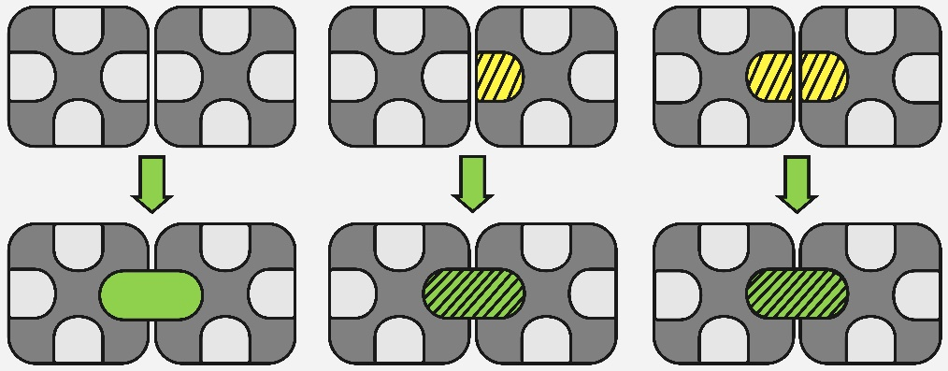

**OBJECTIVE:**

All components on the board must be **collected** as a team. Both players must work together to collect every component and will be scored based on the total number of rounds to finish.

The less turns you take as a team, the more stars you will gain!

**GAMEPLAY RULES:**

At the start of a new round, both players' energy is refreshed by flicking up the four switches on the tool card. Players also flip a switch down on the round counter.

Flicking down a switch equals one use of a tool, and the yellow switch represents a free use of the collect action. **There is no turn order,** players may use their energy and collect at any time. A new round begins when the players run out of energy or decide to.

One player uses the **Cutter** card, and the other uses the **Weaver** card:

|  |  |
| --- | --- |
| **Player 1: CUTTER**  **Cut**: Remove common connector pieces. Hazard connectors cannot be cut.    **Tether**: Create your own connector between two tiles, regardless of distance. Can be Hazard or Standard connectors. | **Player 2: WEAVER**  **Rotate:** Spin the tile. The connections that are attached to the tile move along with it.    **Move**: Slide tiles around. If tiles have connectors, all connected tiles move together. Cannot pass through tiles. |

**COLLECT (any player):**

|  |  |
| --- | --- |
| To win, you must collect all the tiles. Tiles must be collected bysliding **matched** tiles off any side of the board.  Tiles may only be collected so long as all the tiles are of the same color, and do not block each other when sliding out. |  |

**Hazard Connector Rules -** Hazard connectors **cannot** be cut.

**‘Short-circuit!'** - If any tile has 4 hazard connections on itself, the tile “short circuits” and players remove all the hazard connections on that single tile. This can occur both during setup phase, and while using tools.